This week we focused on two tasks

modified TE.sh to sim

a dynamic file list (FILELISTNAME) is created for each file being processed and ${DATA_PATH}${FILENAME} ensures we can automatically change the data path.

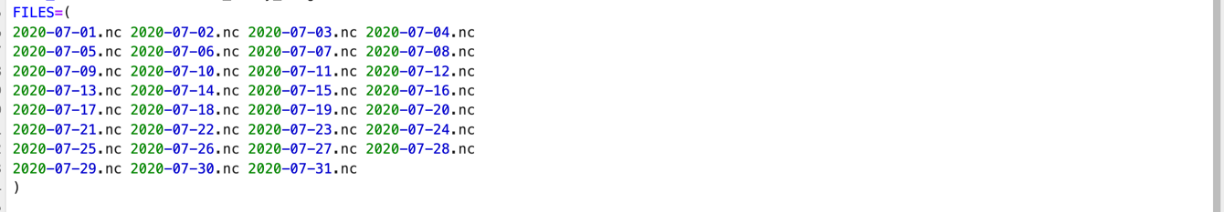

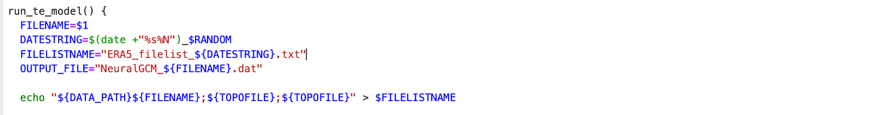

We also set the max files running simultaneously, and use for loop to Process each file sequentially and run_te_model “$file” & enable parallel processing:

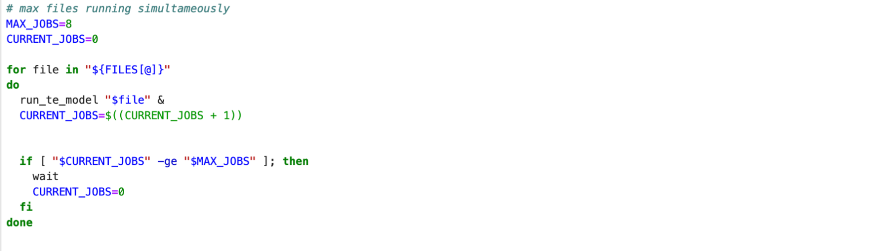

Then we deleted the intermediate files:

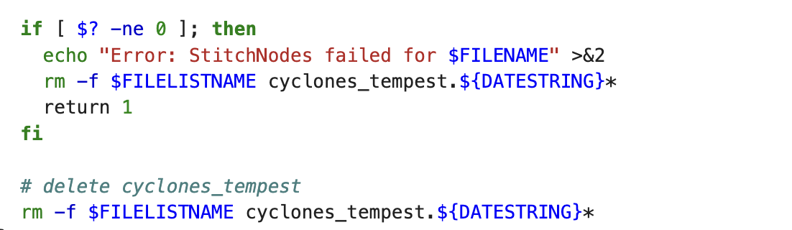

For the 31 parallel datasets obtained from the first task, each providing a 15-day prediction for each day, we first convert all of them into a standardized data format using `label_data.py`, as shown in the diagram below:

Original:

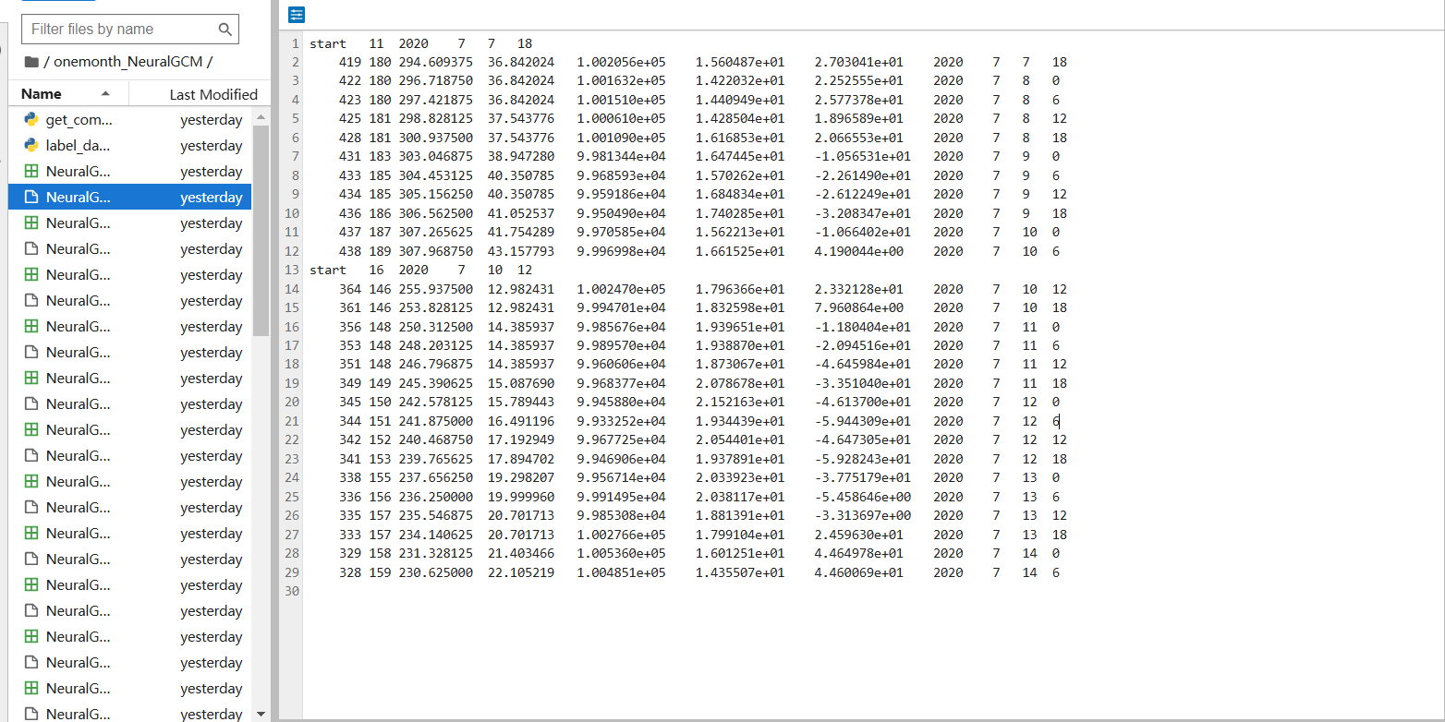

Transferred:

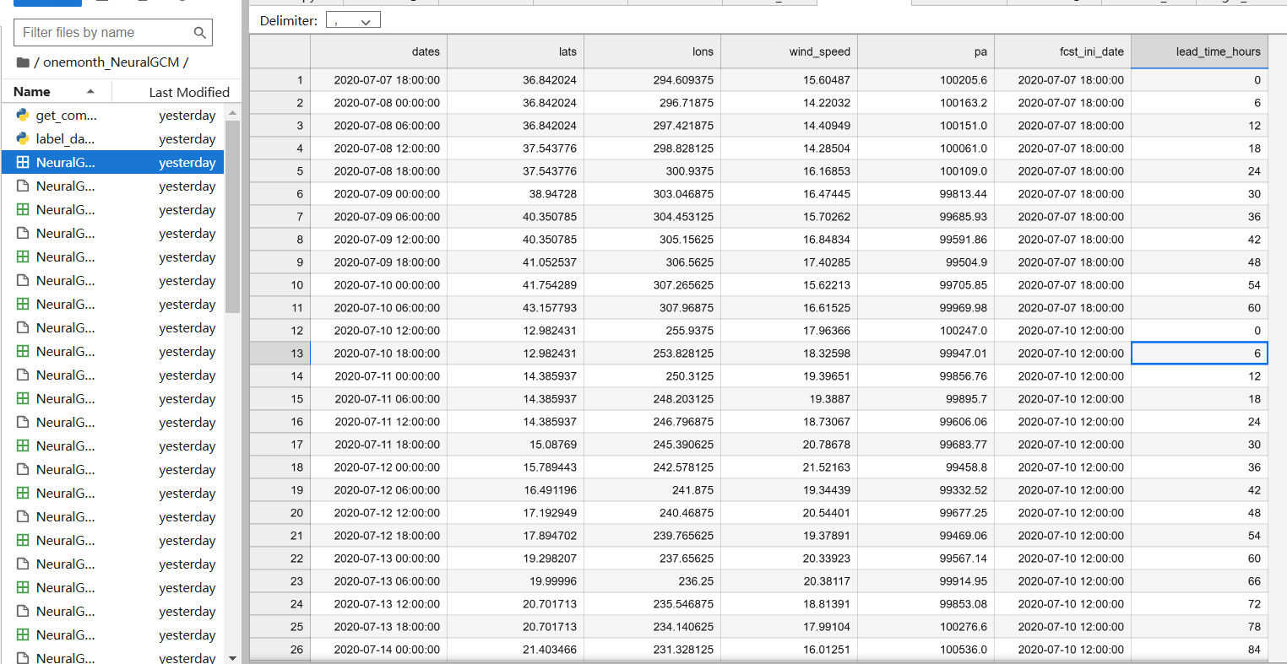

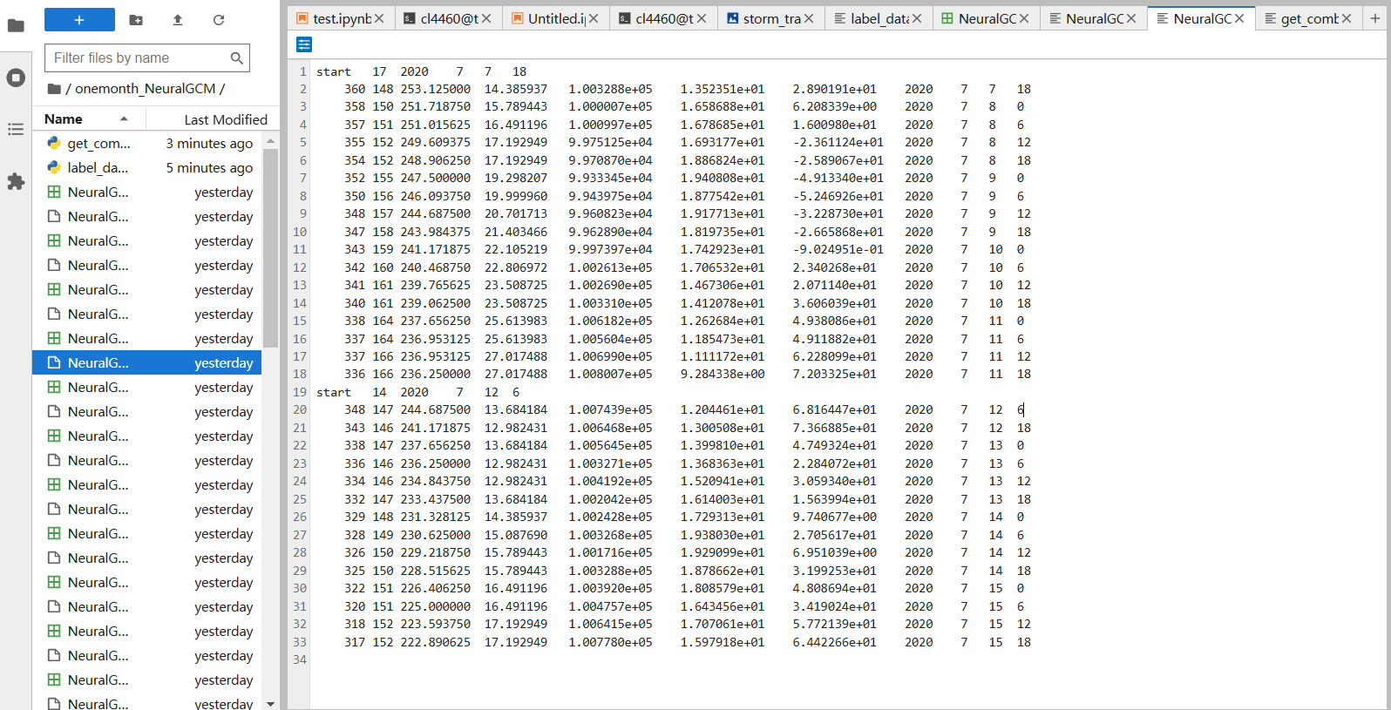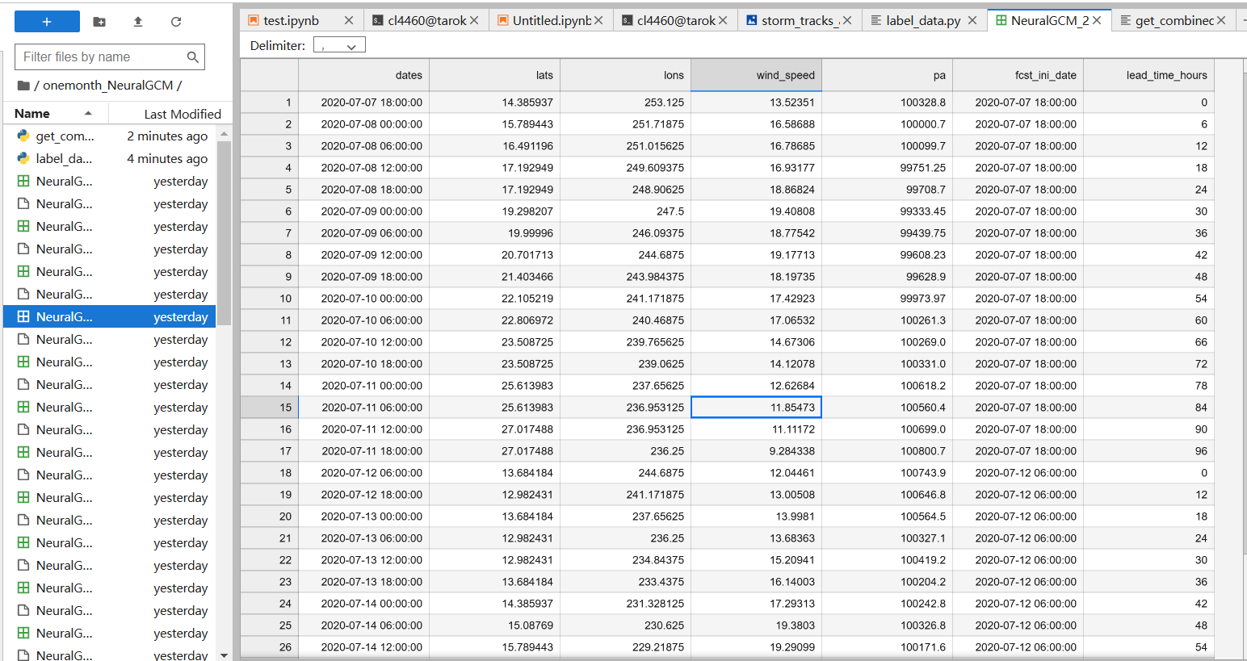

Next, we use `get_combined_graph` to integrate all the data into a single image, resulting in the following outcome:

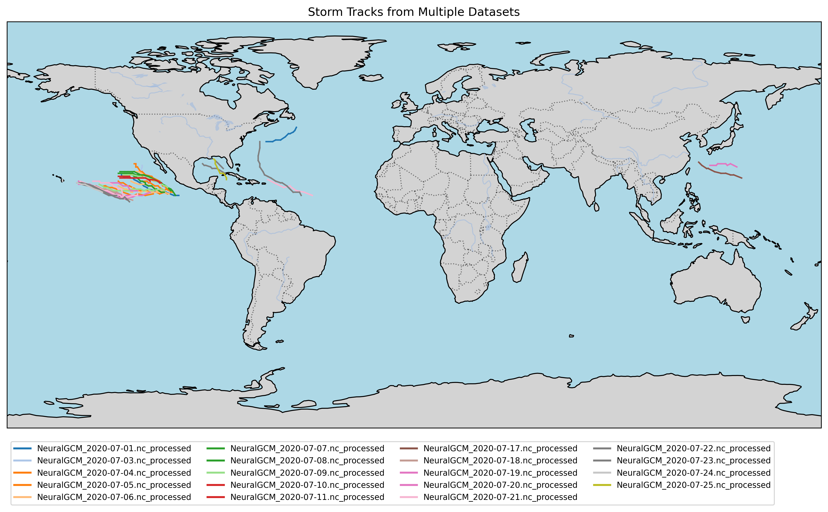

Questions:

We performed reanalysis using the deterministic 0.7-degree NeuralGCM data provided by Abhinav through a modified shell script. For datasets containing a single starting time, none of them were empty. However, when generating results using TempestExtremes, some datasets with specific days as the starting time produced empty outputs. This issue can be observed in the following screenshots as well as in our final output.

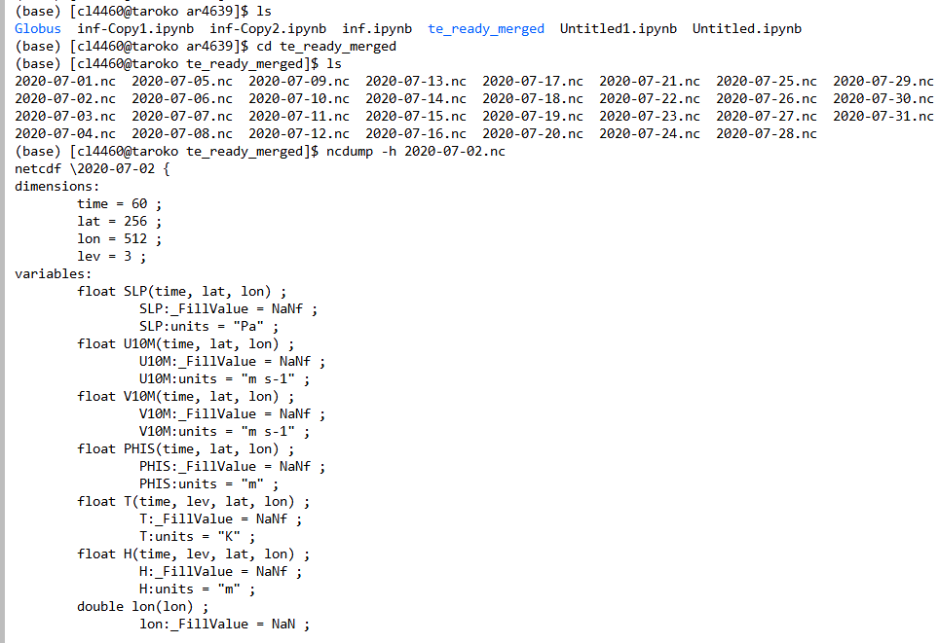

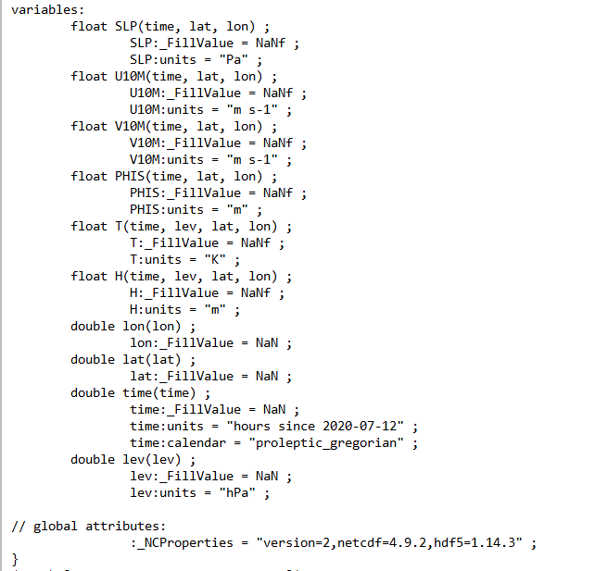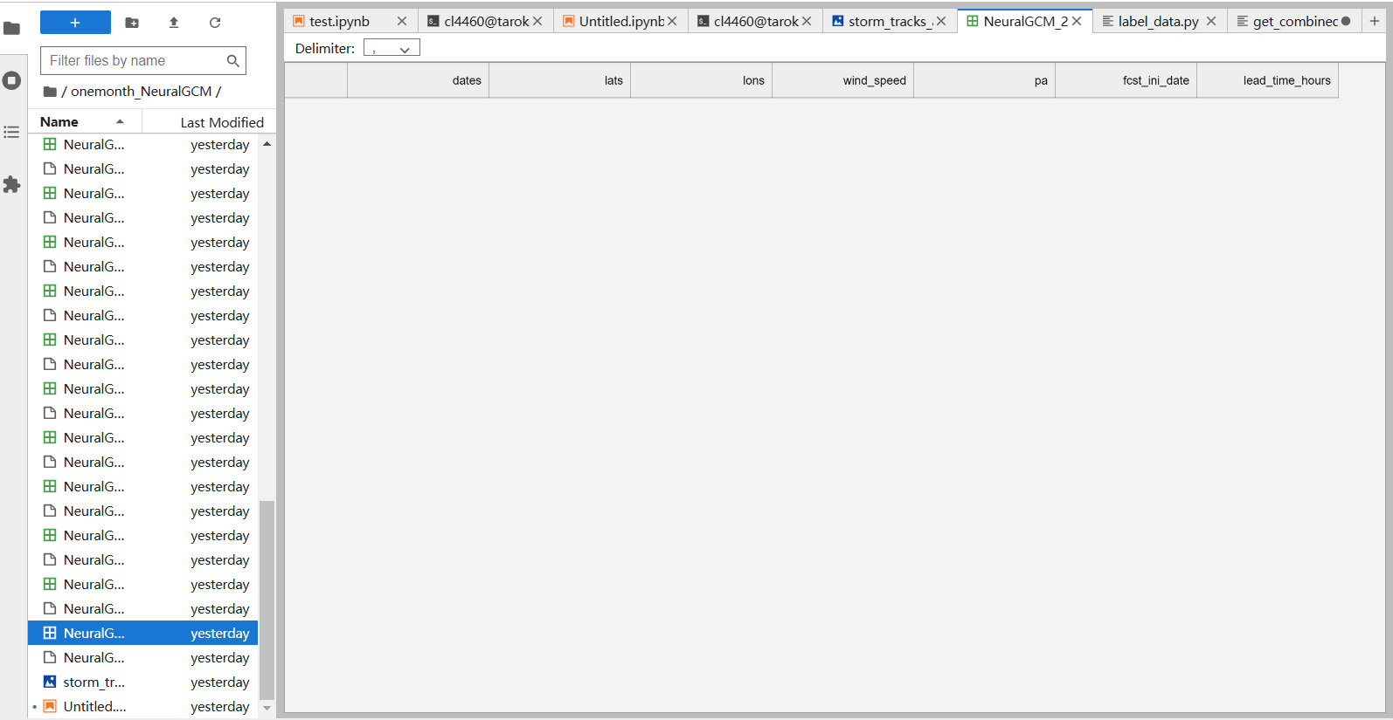

NeuralGCM_2020-07-31.nc_processed.csv